**Our diagrams for Web / UML project**

**Made by All :**

(Table diagram)

**Made by Julien STARCK :**

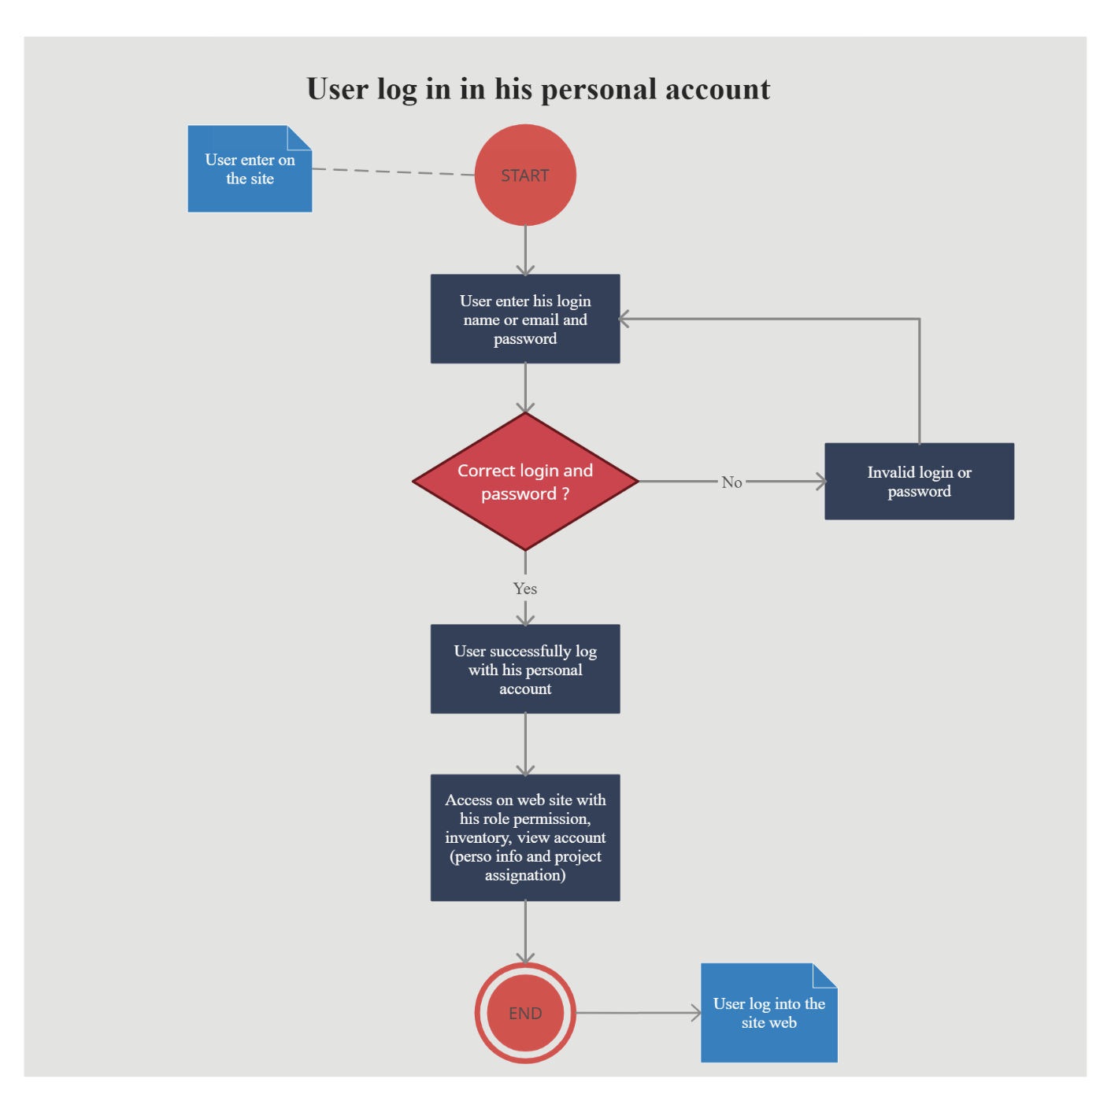

(Activity diagram for user log in)

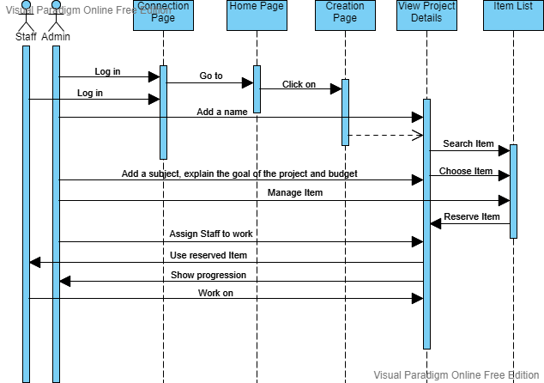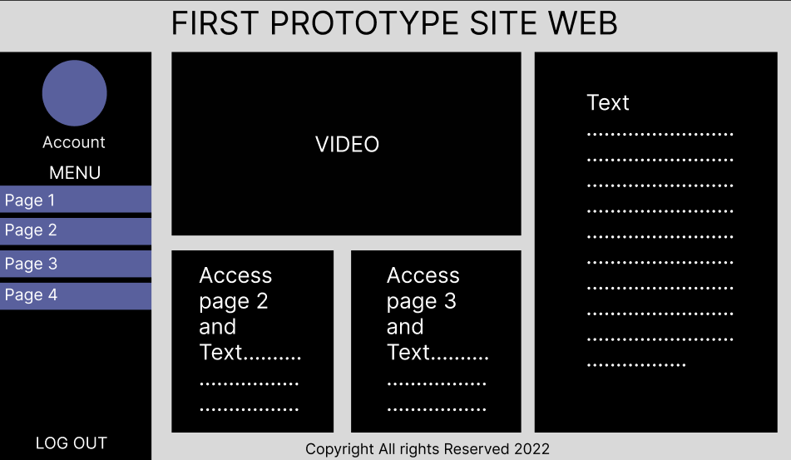

(Sequence diagram to create and work on a project)

(Wireframe of HomePage)

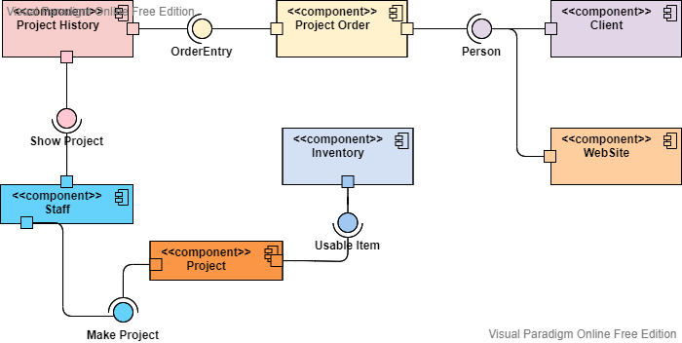

(Component diagram of a project creation)

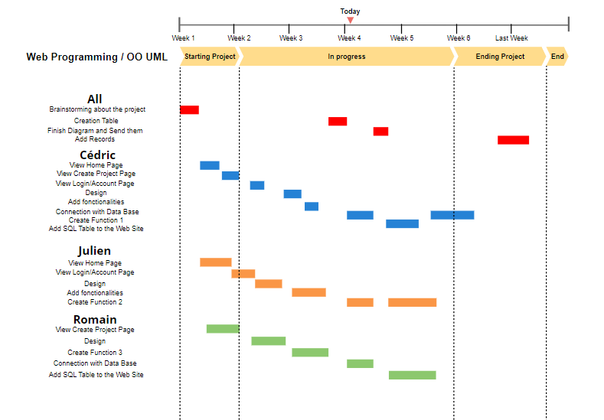

(Gantt diagram)

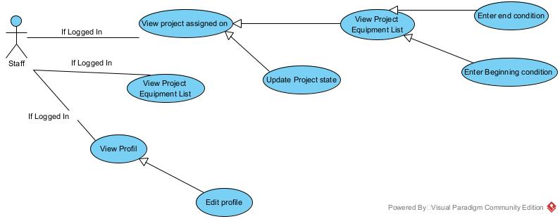

(Use Case Staff)

**Made by Cédric YOGANATHAN :**

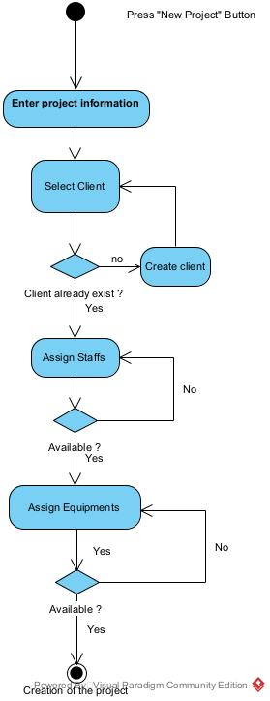

(Activity diagram for project creation)

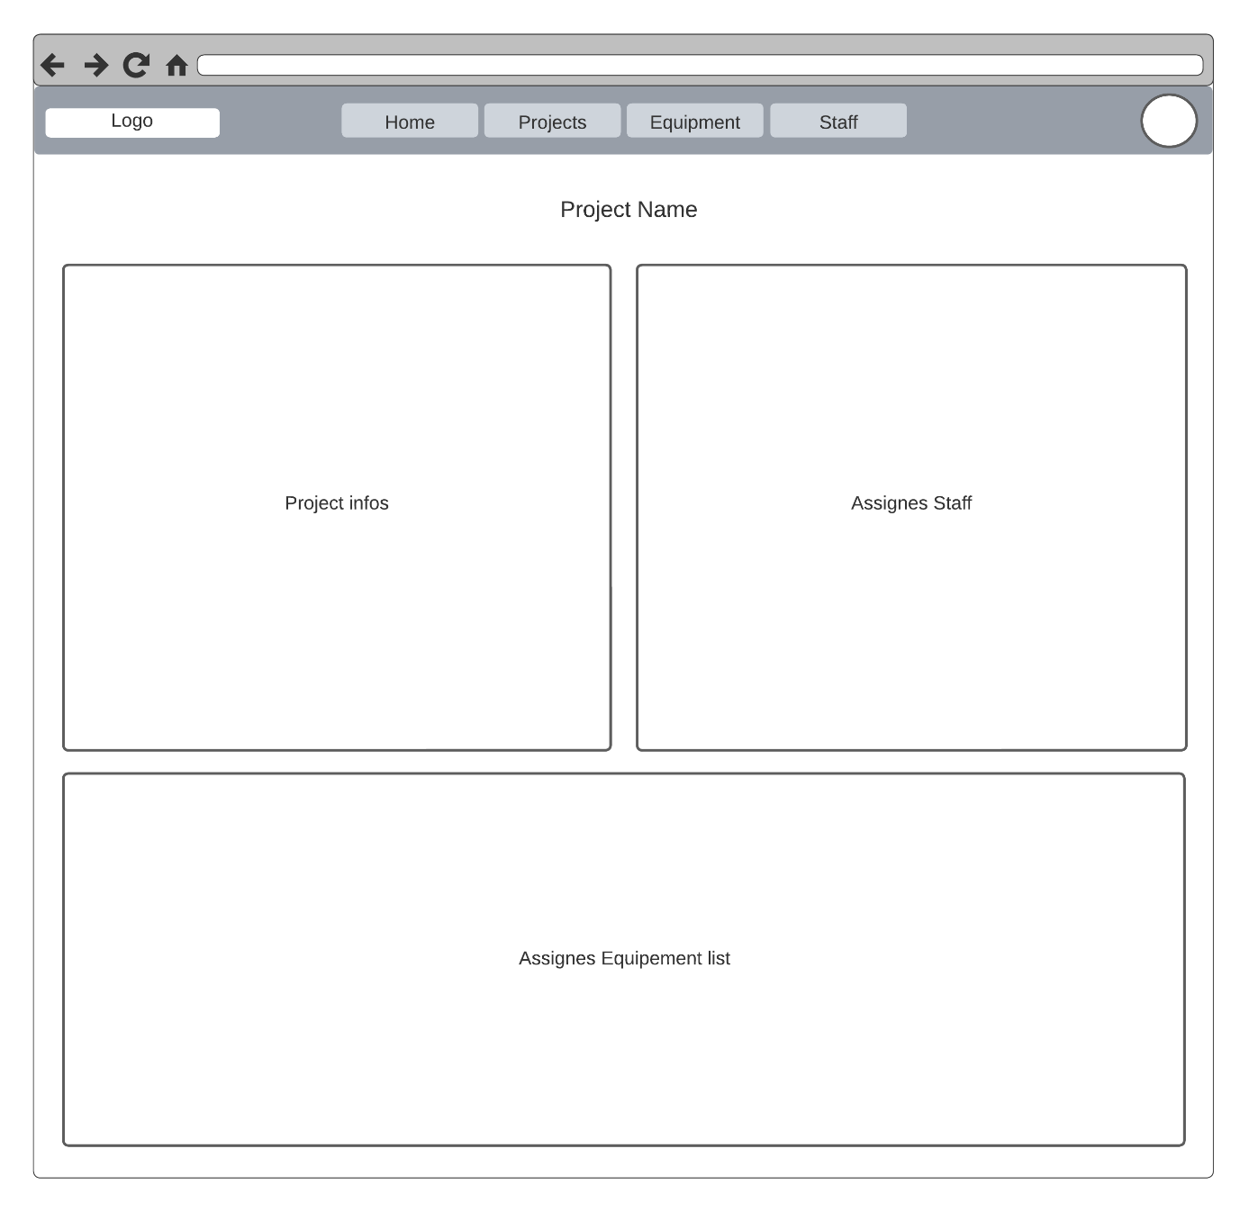

(Wireframe Projects page)

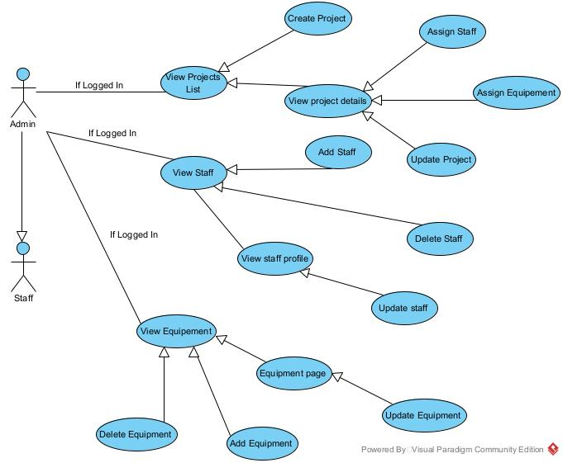

(Use Case diagram Admin)

**Made by Romain DUBOIS :**

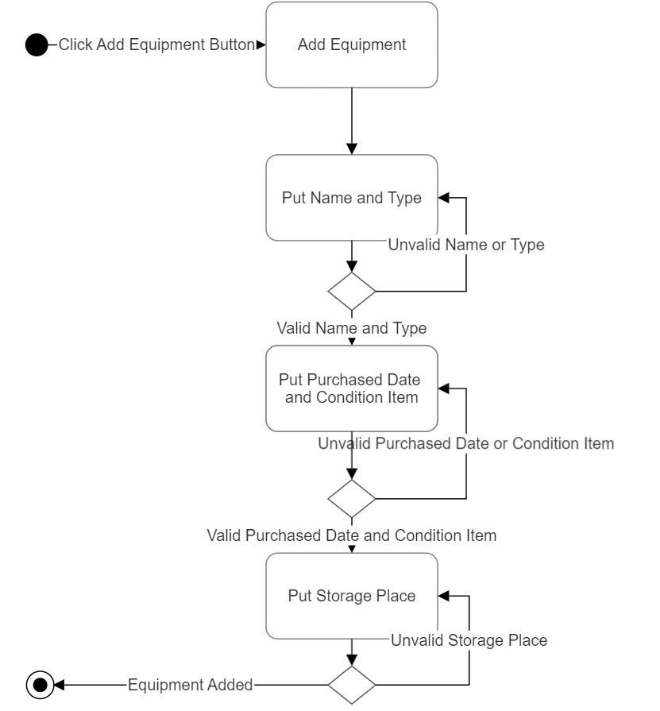

(Activity diagram for adding item)

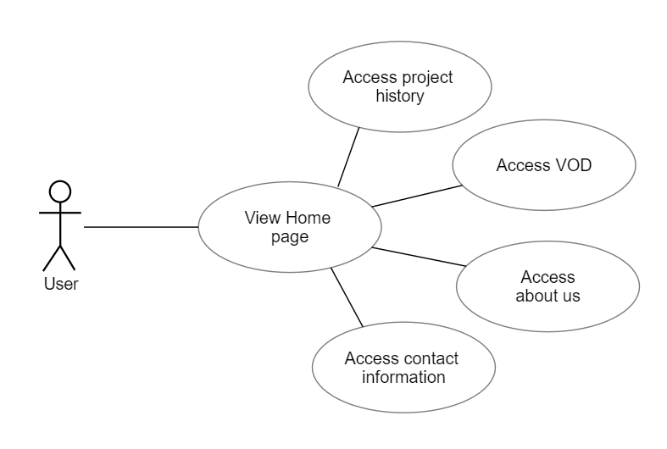

(Use Case diagram of User)